Part 2 Results

Checkpoint 2A: Directory structure
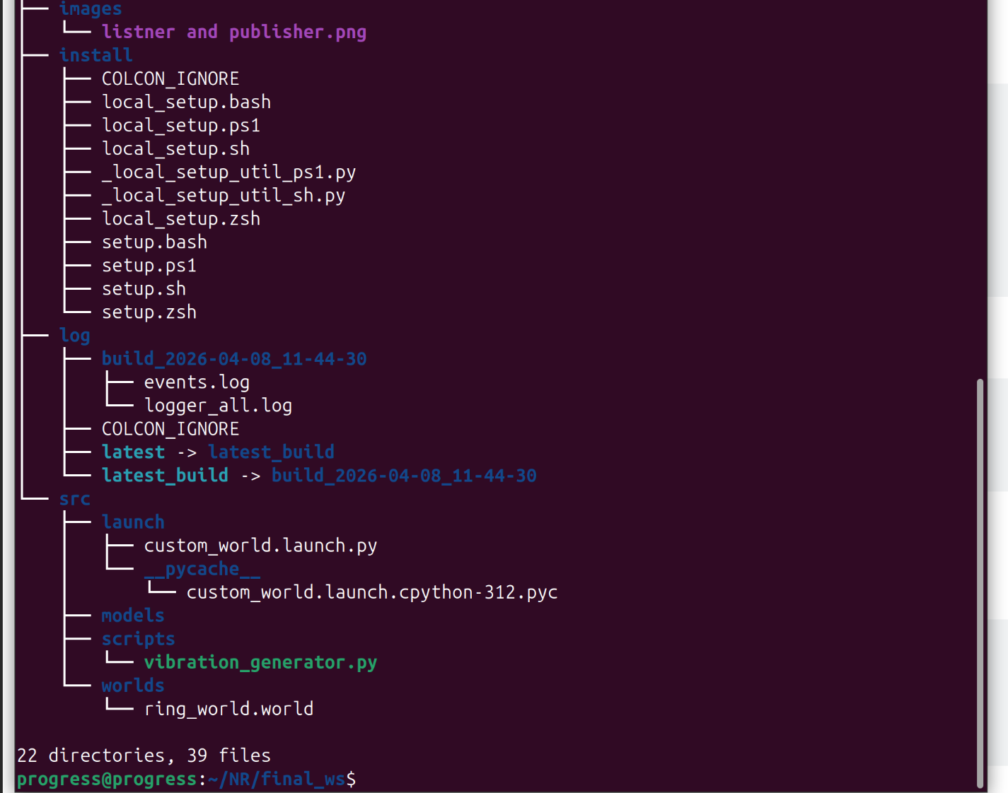

Checkpoint 2B: World file verification
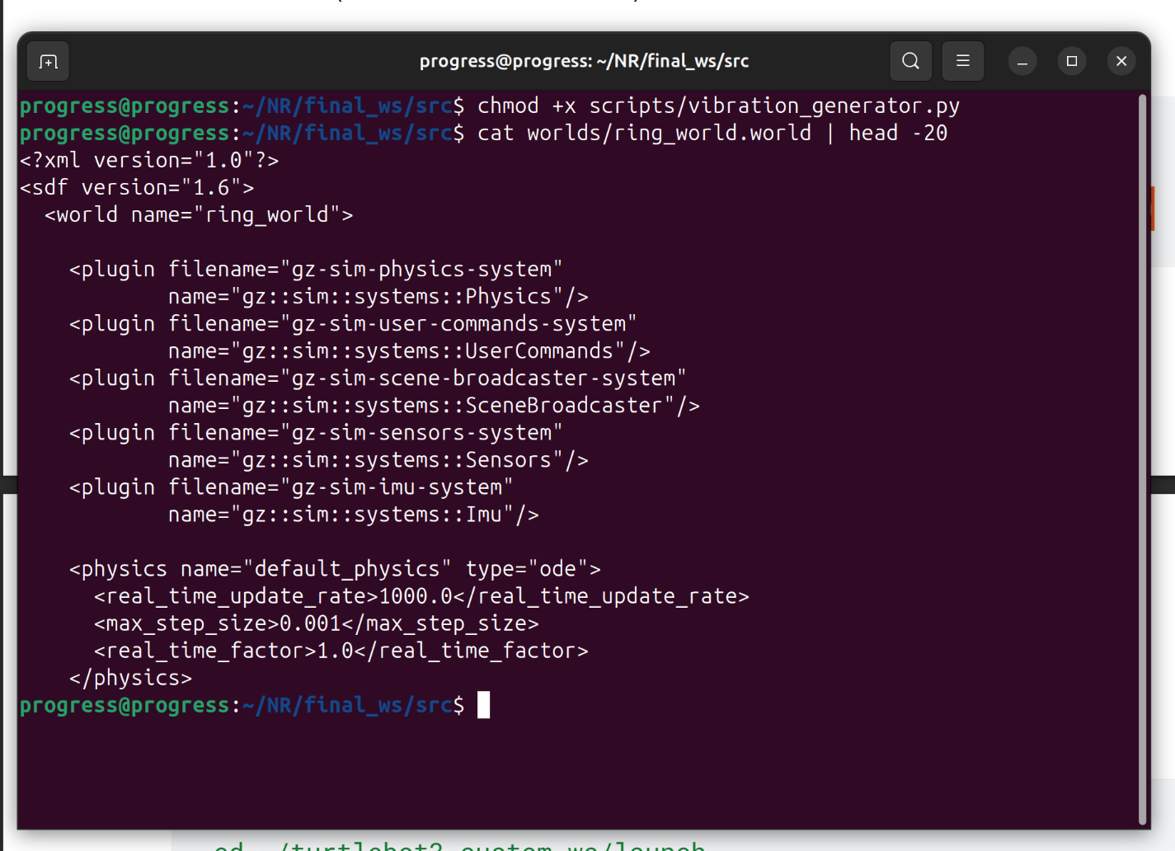

Checkpoint 2C: Script permissions
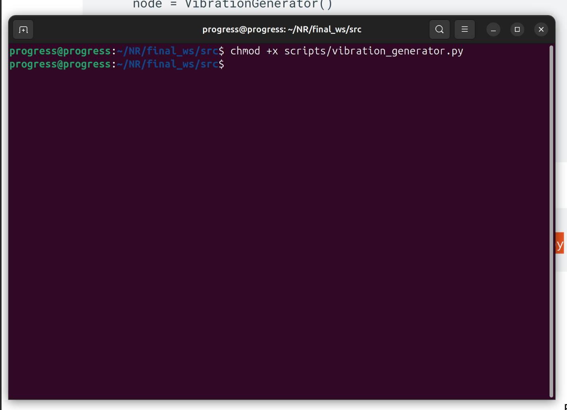

Checkpoint 2D: Custom world screenshot
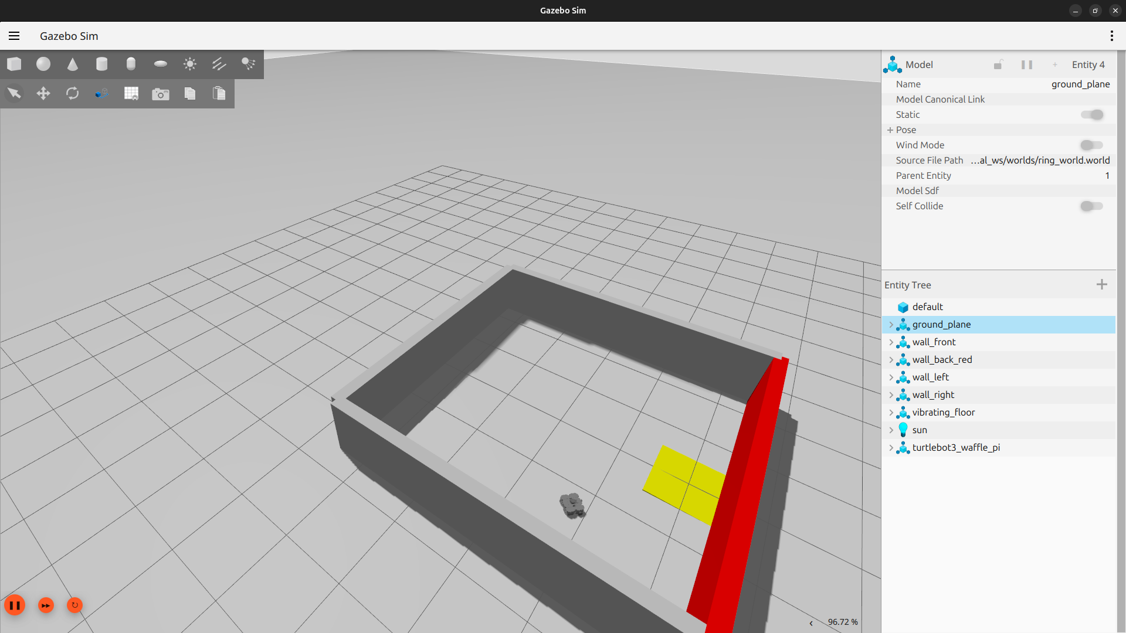

Checkpoint 2E: IMU data screenshot
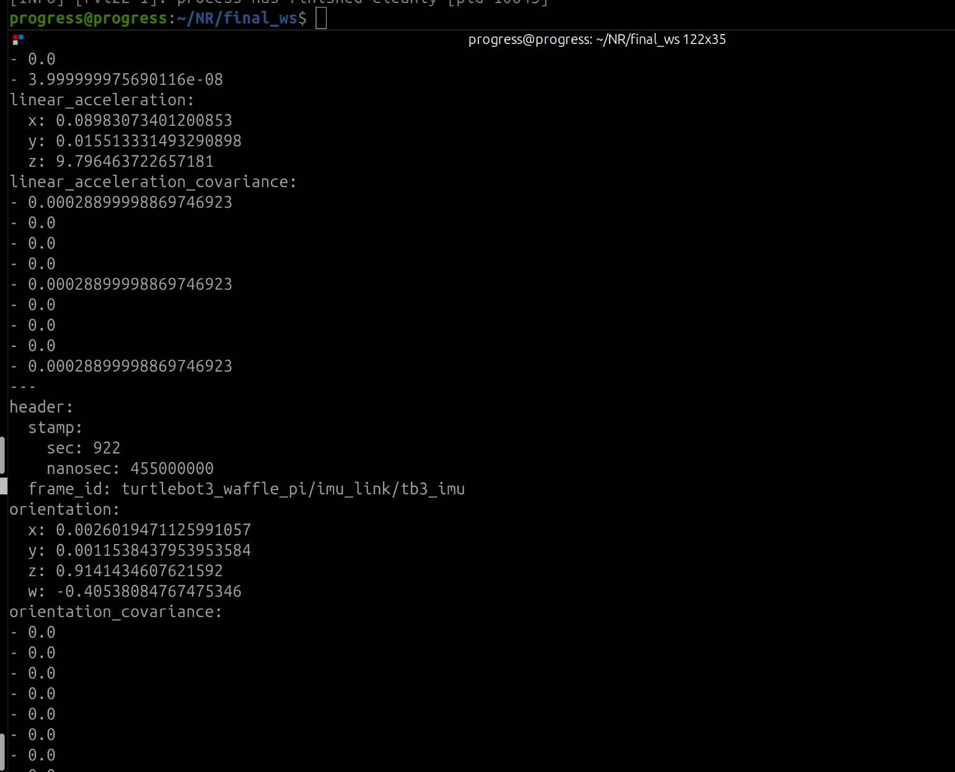

Checkpoint 2F: Vibration analysis
In our IMU data, we observed that the robot produced much larger fluctuations while it was on the vibrating surface than before or after that region. The most significant change appeared in linear_acceleration.z, which suggests that the vibration mainly affected the robot in the vertical direction. We could clearly identify when the robot entered the vibrating zone because the IMU signals became more oscillatory and their variance increased sharply. In a real robot, this behavior could be used to detect rough or vibrating terrain, monitor hardware health, and adapt navigation or control when the robot enters a disturbed environment.

